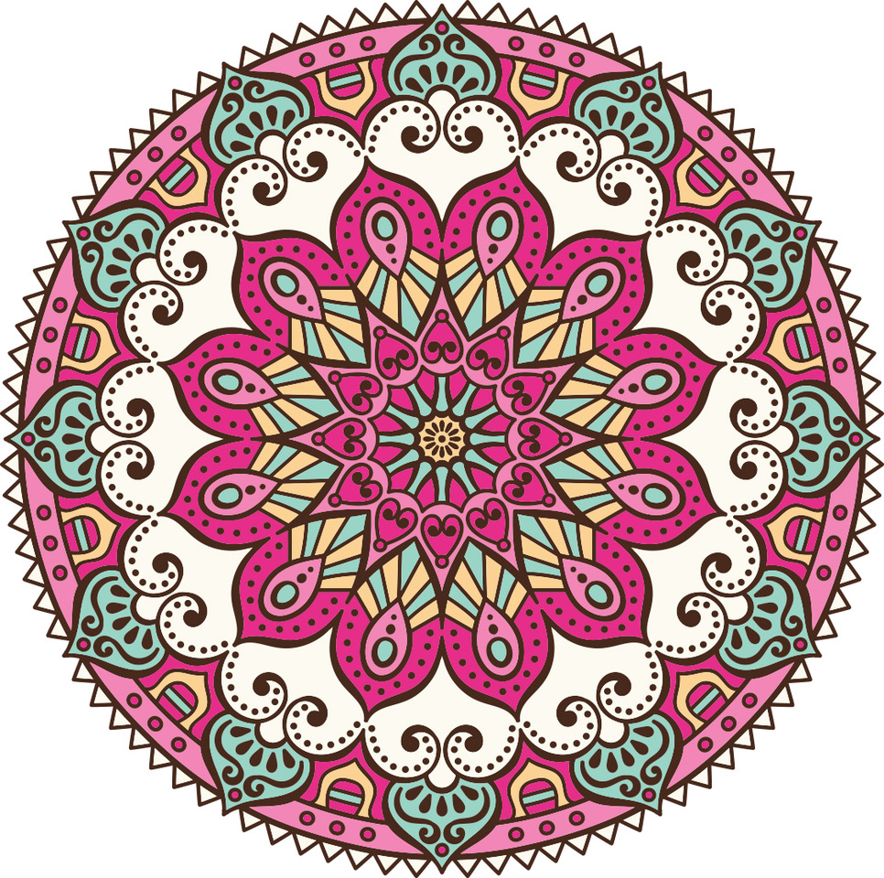

CDG facilitators Newsletter

2nd June 2020

Hi Everyone,
Hope this finds you hale and easeful … here’s a few titbits to enjoy with a cup of tea. :)
Next in the Chalice Foundation blog series: The Leak

Menstruation Matters by Alana Munro, post-graduate researcher, Sydney University
As I waited for the tour guide in the lobby of our hotel in Siem Reap, Cambodia, I began to wonder where my travel companion was. Emerging from the lobby bathroom, she shrieked that her period had unexpectedly arrived. A period in a South-East Asian country – where it was more common for menstruation to be shrouded in secrecy than shouted in celebration, and where it seemed like mission impossible to find menstrual products at the local store – felt like a terrifying burden. I reflect on this because it was my “ah-ha” moment. If it was already so troublesome for a tourist to manage their monthly menses on holiday, how difficult would it be for local women and girls? More
Periods and the Guy in Red
An interview by Casimera Mellican with Freya Bennett
Q: How was it having no periods during your pregnancy? Was it strange and did you keep expecting them, or was your concentration in a completely different space?
A: I completely forgot about periods. I think because I was so focused on my pregnancy and because things change so much month to month, there really is no room to ‘miss’ a period. It’s just a completely different way of being! More
Sign up for Chalice Foundation blog updates here.
Activate Your Female Power
I’m really enjoying Sharon Maloney’s Activate Your Female Power. She combines contemporary research about female physiology and biochemistry, with a mature perspective of female embodied spirituality.
Sharon is offering a free ebook, Female Hormones Part 1, which I highly recommend – available here.
Sharon is a researcher that we often reference, especially for her paper ‘How Menstrual Shame Effects Birth’: https://www.womenandbirth.org/article/S1871-5192(10)00023-5/pdf
Check out the ‘Endo Girl’
a short film trailer about endometriosis: https://vimeo.com/326671376
Made by a dancer / film-maker, Sophia Bender, who has endometriosis.
2020 CDG Manual
You simply must check out the much refreshed and updated content (by Trainer Team, especially Janoel Liddy and Jane Bennett) and sparkling design by Mariana Zavery. Go to the ‘CDG Materials’ page of the facilitator section of the website, scroll down to the bottom and there it is to download. Enjoy!!!
Can I make an income running Celebration Day for Girls?
I know this is a question many facilitators have asked themselves before and after training, and I have just added this question and my response to the Training page. I know it’s somewhat after the fact for you, but it’s long been a question I wanted to more fully explore with facilitators and those considering training. To check it out scroll down the page to the questions bordered by pink, and go to the last question (as above). Let me know what you think … :)
Facilitation Skills for Celebration Day for Girls
We had a great turnout on Wednesday 27th for the first in our series: PD Pearls.
If you missed it or would like to go again here’s the link (for audio, video and chat box)
https://us02web.zoom.us/rec/share/xZQqKamz7F5LedbQ0R_7ZqEhM9S8X6a8h3Qf_fJczUmH4GtTpVvNWMj7roelNL8e?startTime=1590569243000
Janoel Liddy is planning a follow up session in a couple of months, so if you didn’t get to this one and would like to catch the next one, do check out the recording.
Hope you’re holding steady in the current transient normal, on the way to yet another, but as yet unknown, normal … and along the way finding precious treasures to be grateful for.
Warmest wishes and blessings,
Jane

