The Menstrual Cycle by Armando Hasundungan

Notes by Kath Callinan-Moore from :
https://www.youtube.com/watch?v=2_owp8kNMus&app=desktop (excellent clip!)

We begin with 2 important parts of the brain:
Hypothalamus + Pituitary Gland (anterior and posterior) - [see attached explanatory notes]
Focus on anterior lobe of the pituitary. Hypothalamus regulates hormones released by the ant. pituitary through its portal blood flow.
Hypothalamus produces Gonadotrophin Releasing Hormone (GnRH) which travels to the ant. pituitary via the portal blood vessels and causes the ant. pituitary to produce
Follicle Stimulating Hormone(FSH) and Luteinizing Hormone(LH).
[Note that in males this exact same process occurs with regard to GnRH, FSH and LH]

These 3 hormones travel via the blood stream to the Ovaries where eggs are produced.
In each ovary are an abundance of follicles. Each month some begin to mature but only one will ovulate i.e. release an egg.
The Menstrual Cycle is divided into 2 phases: first 14(or so) days= Follicular Phase
second 14(or so) days= Luteal Phase

Initially ↑GnRH secreted by the hypothalamus causes a steady rise in FSH and LH.
Then a slow drop in FSH occurs while LH continues to rise very slowly.

As FSH rises it stimulates the continuing maturation of the egg-containing follicles.
Some of these primary follicles will mature into secondary follicles.
While follicles are maturing they produce Oestrogen (a hormone with many effects and the female equivalent of the male’s testosterone)
In the first 10 days of the cycle, oestrogen has a negative feedback effect on the pituitary gland inhibiting the release of LH.
At low concentrations of oestrogen there will be LH inhibition, hence its quite slow rise.
At the same time FSH will also be affected as once oestrogen begins to rise FSH will also be inhibited and levels will begin to fall.

[Note: Oestrogen is also responsible for:
- stimulating bone and muscle growth
- stimulating growth of the endometrium (uterine lining)
- maintains ♀secondary sexual characteristics
- maintains glandular/breast tissue]

As follicles mature they produce more oestrogen.
After 10 days, with oestrogen levels continuing to rise, its feedback effect changes to positive, stimulating a rise in LH.
So then there is a combined effect of the GnRH and the high oestrogen level boosting LH secretion and causing a large spike in the LH level.
It’s this spike effect that triggers ovulation of the most mature follicle on the ovary surface and the egg (oocyte) is released.

After ovulation LH levels drop dramatically.
GnRH slowly drops.
FSH also has a small spike at ovulation as a side-effect of the LH surge.

After the follicle ovulates it turns into a Corpus Luteum (Latin for “yellow body”) and is essentially a dead follicle.

So now the second phase of the Menstrual Cycle begins - the Luteal Phase.
The corpus luteum will slowly degrade but has an important role secreting 3 hormones:
Oestrogen, Progesterone and Inhibin.

Oestrogen will rise until ovulation then fall slightly.
Inhibin, not present until after ovulation, will begin to rise. It will now inhibit FSH and any further follicular maturation.
Progesterone levels are low until after ovulation but then this hormone becomes the most important.
Its functions include:
- negative feedback effect on the hypothalamus, inhibiting the secretion of GnRH (the drop in oestrogen will also suppress GnRH)
- the key function of stimulating endometrial growth in preparation for implantation should fertilisation occur.

If no fertilisation occurs the corpus luteum will degenerate and hormone levels will drop which will allow GnRH to rise again and commence a new cycle.
The lack of oestrogen and progesterone also means that the uterine lining cannot be maintained and so the endometrium will be shed and the bleeding time will begin.

The hypothalamus
Last updated Wed 22 August 2018
By Jon Johnson
Reviewed by Daniel Murrell, MD

The hypothalamus is a small but important area in the center of the brain. It plays an important role in hormone production and helps to stimulate many important processes in the body and is located in the brain, between the pituitary gland and thalamus.
When the hypothalamus is not working properly, it can cause problems in the body that lead to a wide range of rare disorders. Maintaining hypothalamic health is vital because of this.

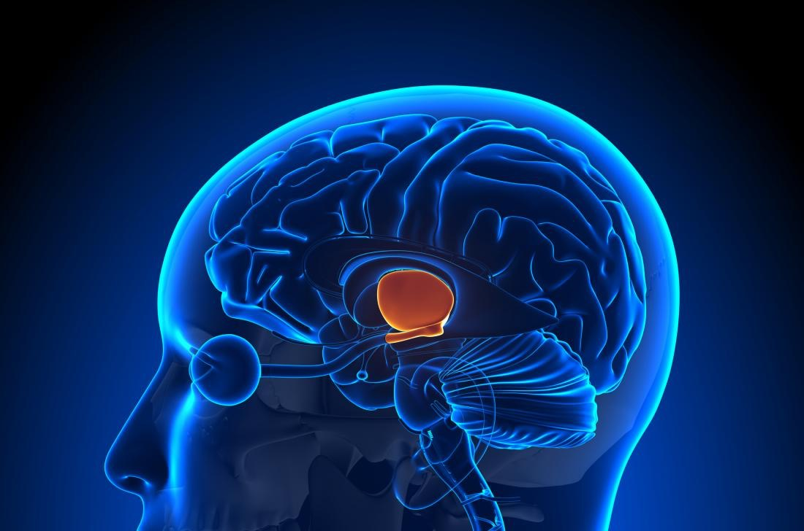

Function

The hypothalamus is a small but essential part of the brain.
The hypothalamus' main role is to keep the body in homeostasis as much as possible.
Homeostasis means a healthful, balanced bodily state. The body is always trying to achieve this balance. Feelings of hunger, for example, are the brain's way of letting its owner know that they need more nutrients to achieve homeostasis.
The hypothalamus acts as the connector between the endocrine and nervous systems to achieve this. It plays a part in many essential functions of the body such as:
• body temperature
• thirst
• appetite and weight control
• emotions
• sleep cycles
• sex drive
• childbirth
• blood pressure and heart rate
• production of digestive juices
• balancing bodily fluids
As different systems and parts of the body send signals to the brain, they alert the hypothalamus to any unbalanced factors that need addressing. The hypothalamus then responds by releasing the right hormones into the bloodstream to balance the body.
One example of this is the remarkable ability of a human being to maintain an internal temperature of 98.6 °Fahrenheit (ºF).

If the hypothalamus receives a signal that the internal temperature is too high, it will tell the body to sweat. If it receives the signal that the temperature is too cold, the body will create its own heat by shivering.

Hormones of the hypothalamus
To maintain homeostasis, the hypothalamus is responsible for creating or controlling many hormones in the body. The hypothalamus works with the pituitary gland, which makes and sends other important hormones around the body.
Together, the hypothalamus and pituitary gland control many of the glands that produce hormones of the body, called the endocrine system. This includes the adrenal cortex, gonads, and thyroid.
Hormones secreted by the hypothalamus include:
• antidiuretic hormone, which increases how much water is absorbed into the blood by the kidneys
• corticotropin-releasing hormone, which helps regulate metabolism and immune response by working with the pituitary gland and adrenal gland to release certain steroids
• gonadotropin-releasing hormone, which instructs the pituitary gland to release more hormones that keep the sexual organs working
• oxytocin, a hormone involved in several processes, including the release of a mother's breast milk, moderating body temperature, and regulating sleep cycles
• prolactin-controlling hormones, which tell the pituitary gland to either start or stop breast milk production in lactating mothers
• thyrotropin-releasing hormone activates the thyroid, which releases the hormones that regulate metabolism, energy levels, and developmental growth
The hypothalamus also directly influences growth hormones. It commands the pituitary gland to either increase or decrease their presence in the body, which is essential for both growing children and fully developed adults.

-.-.-.-.-.-.-.-.-.-.-.-.-.-.-.-.-.-.-.-.-.-.-.-.-.-.-.-

The Pituitary Gland

What is the pituitary gland?
The pituitary gland is a part of your endocrine system. Its main function is to secrete hormones into your bloodstream. These hormones can affect other organs and glands, especially your:
• thyroid
• reproductive organs
• adrenal glands
The pituitary gland is sometimes called the master gland because it’s involved in so many processes.

Pituitary gland anatomy and function
The pituitary gland is small and oval-shaped. It’s located behind your nose, near the underside of your brain. It’s attached to the hypothalamus by a stalklike structure.
The hypothalamus is a small area of your brain. It’s very important in controlling the balance of your bodily functions. It controls the release of hormones from the pituitary gland.
The pituitary gland can be divided into two different parts: the anterior and posterior lobes.

Anterior lobe
The anterior lobe of your pituitary gland is made up of several different types of cells that produce and release different types of hormones, including:
• Growth hormone. Growth hormone regulates growth and physical development. It can stimulate growth in almost all of your tissues. Its primary targets are bones and muscles.
• Thyroid-stimulating hormone. This hormone activates your thyroid to release thyroid hormones. Your thyroid gland and the hormones it produces are crucial for metabolism.
• Adrenocorticotropic hormone. This hormone stimulates your adrenal glands to produce cortisol and other hormones.
• Follicle-stimulating hormone. Follicle-stimulating hormone is involved with oestrogen secretion and the growth of egg cells in women. It’s also important for sperm cell production in men.
• Luteinizing hormone. Luteinizing hormone is involved in the production of oestrogen in women and testosterone in men.
• Prolactin. Prolactin helps women who are breastfeeding produce milk.
• Endorphins. Endorphins have pain-relieving properties and are thought to be connected to the “pleasure centers” of the brain.
• Enkephalins. Enkephalins are closely related to endorphins and have similar pain-relieving effects.
• Beta-melanocyte-stimulating hormone. This hormone helps to stimulate increased pigmentation of your skin in response to exposure to ultraviolet radiation.

Posterior lobe
The posterior lobe of the pituitary gland also secretes hormones. These hormones are usually produced in your hypothalamus and stored in the posterior lobe until they’re released.
Hormones stored in the posterior lobe include:
• Vasopressin. This is also called antidiuretic hormone. It helps your body conserve water and prevent dehydration.
• Oxytocin. This hormone stimulates the release of breast milk. It also stimulates contractions of the uterus during labor.

