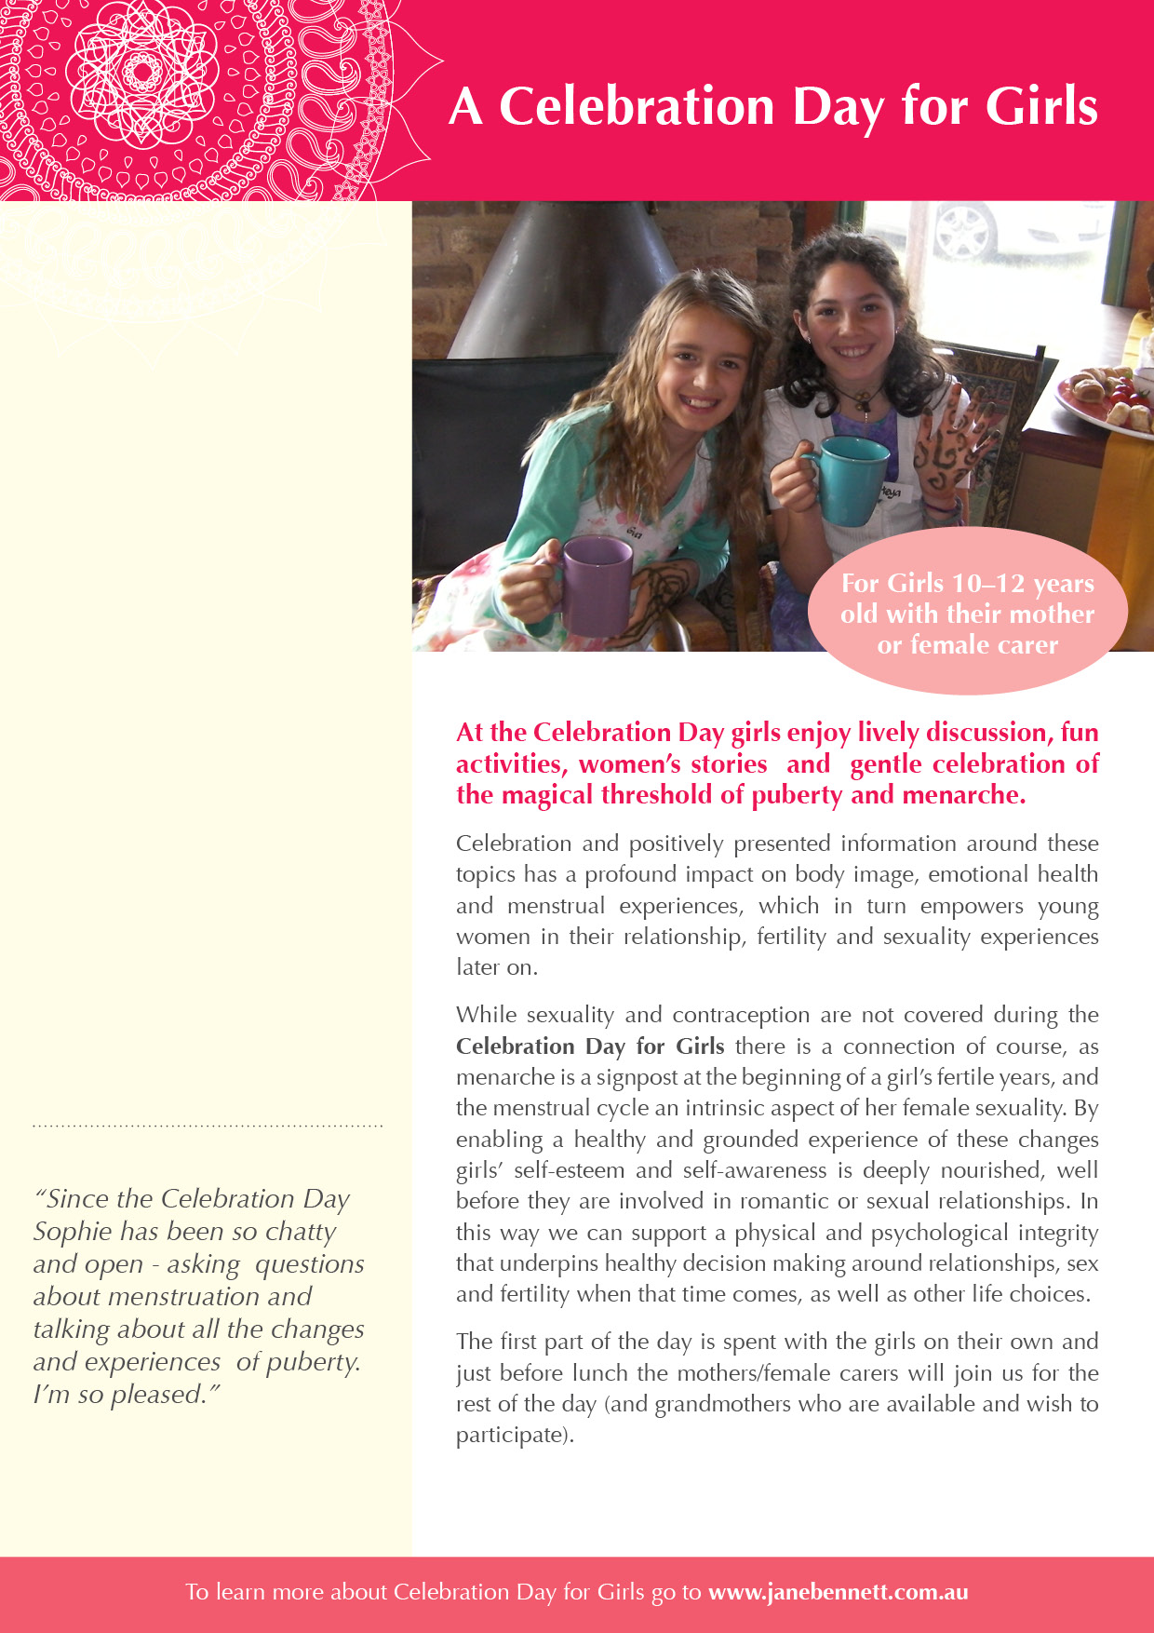

* **Secret Girls Business** by Angelo,F , Pritchard, H., & Stweart R. (2003)
* **A Blessing not a Curse** by Jane Bennett (2002
* **The Pill: Are you sure it’s for you?** By Jane Bennett & Alexandra Pope (2008)
* **Red Moon – Understanding and using the creative, sexual and spiritual girts of the menstrual cycle** by Miranda Gray (2009)
* **Optimized Woman – using your menstrual cycle to achieve success and fulfillment** by Miranda gray (2009)
* **Passage to Power** by Leslie Kenton (1995)
* **Ayurveda Healing for Women** by Atreya (1999)
* **The mask of motherhood** by Susan Maushart (1997)
* **Ayurveda for Women** by Robert Svoda (2000)
* **The Wild Genie – the healing power of menstruation** by Alexandra Pope (2001)
* **Her Blood is Gold** by Laura Owen (1993)
* **Mother-Daughter Wisdom: Crating a Legacy of Physical and Emotional Health** by Christine Northrup (2005)
* **Puberty Girl** by Shushann Movsessian (2004)
* **Natural Fertility** by Francesca Naish (1991)
* **The Secret Lives of Teen Girls** by Evelyn Resh (2009)
* **Why Gender Matters** by Leonard Sax (2006)
* **Raising Drug-free Kids** by Aletha Solter (2006)
* **Flow: The cultural Story of Menstruation** by Elissa Stein & Susan Kim (2009)
* **Queen Bees and Wannabees** by Rosalind Wiseman (2009)
* **The Butterfly Effect** by Dannielle Miller (2009)

Some great books to read…

Checklist for Mums